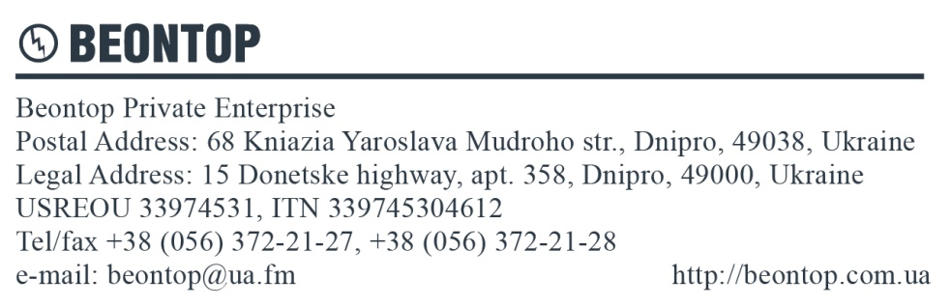

Questionnaire
for ordering voltage transformers
Company name:
Contact person:
Telephone Fax E-mail

Parameter name | Parameter value
Type of transformer (underline) | IVS1 (grounded),  IVD1 (ungrounded), 3xIVS1 (group)
Fuse (underline) | Yes No
Rated voltage of primary winding, [kV]
Secondary windings purpose (underline) | - For measurement  - For protection  - Residual | - For measurement  - For protection  - Residual | - For measurement  - For protection  - Residual
Rated voltage of secondary winding, [V]
Accuracy class
Rated burden, [VA]
Thermal limiting output, [VA]
Climatic performance and category of placement
Quantity, pcs.
Desired shipping date
Notes:

Date:____________ Signature ______________

